Organic Rainbow Carrots Information Pack
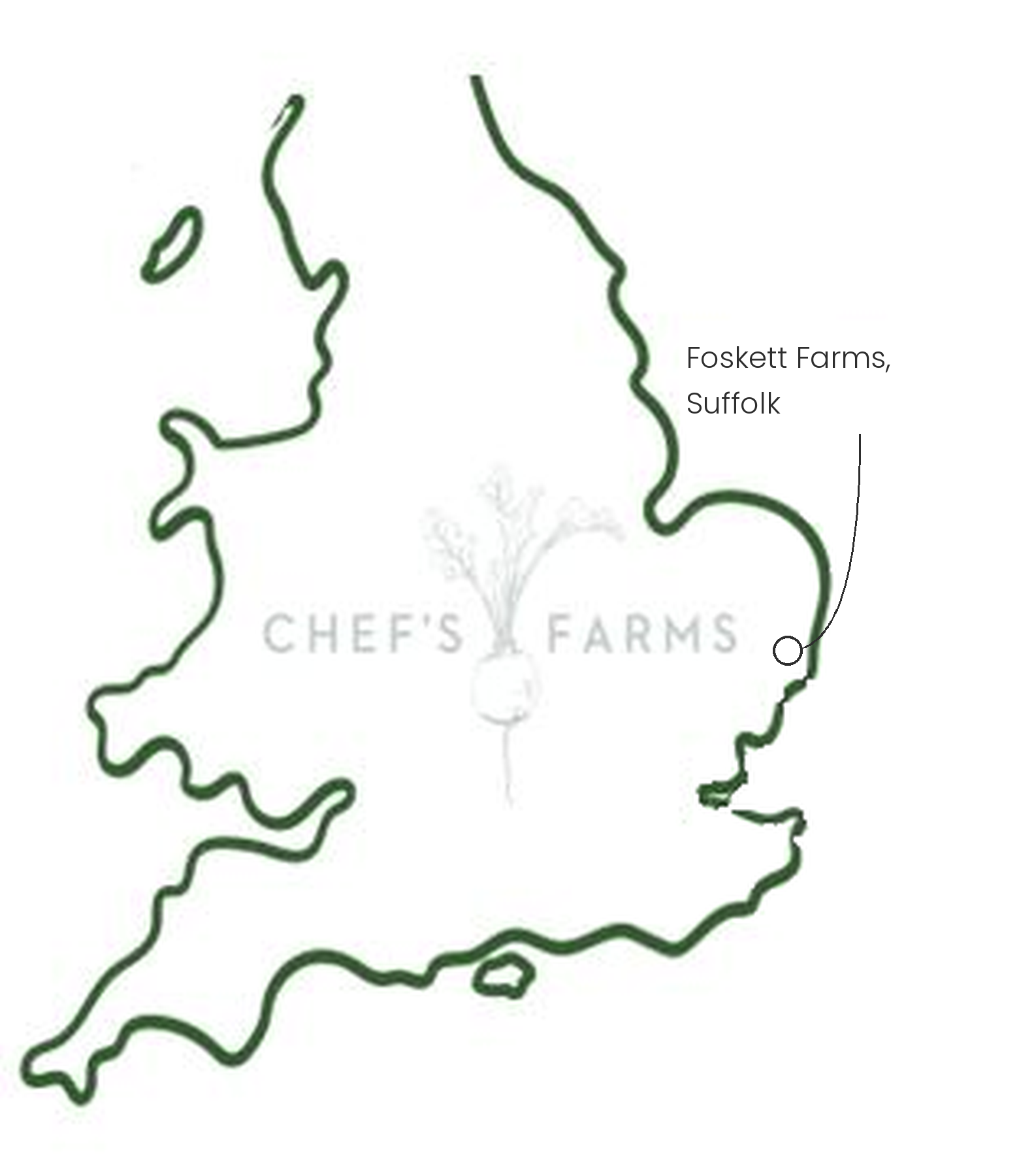
Introduction
The first cultivated carrots were purple and yellow; the orange carrot we know today was bred much later, in 17th century Holland. Rainbow carrots bring those older colours back to the plate, and each colour has a slightly different flavour and sweetness.
Farm Information
Our organic rainbow carrots are grown by James and Jess Foskett at Foskett Farms in Suffolk. James is the second generation of the family to farm here and moved much of the land into organic production when he took over.
Carrots are one of the trickiest crops to grow organically. They are slow to germinate and their fine, feathery leaves cast very little shade, so weeds can easily outcompete them. Rather than spraying, the Fosketts use large laser weeding machines that pick out the weeds between the carrots and zap them, keeping the crop clean without any agrichemicals.
The farm runs a long crop rotation with cover crops between cash crops, so carrots only return to the same field after a good break. This keeps soil-borne pests such as carrot fly from building up, while the cover crops keep living roots in the ground, feeding the soil and protecting it from erosion. Jess is now exploring regenerative certification to take this further.
This summer's drought was hard on the carrots. But years of organic soil management, long rotations and cover crops have built soil that holds far more water than heavily degraded ground, so the crop was much less badly affected than it would otherwise have been.
We are incredibly proud to support James, Jess and the team.
More
UK carrots are harvested from early summer and store well in the ground and in cold store through the winter. Roast the colours whole or shave them raw to show them off; purple carrots bleed their colour when boiled, so keep them separate or cook them dry.
Nutritionally, each colour comes from a different natural pigment: beta-carotene in the orange, lutein in the yellow and anthocyanins in the purple, all of which are antioxidants. Being organic, they are free from agrochemical residue.
Media
See shared album

